**EXPERIMENT NO:3**

**AIM: Case study on Manufacturing and Material Handling System.**

Raw materials form a critical part of manufacturing as well as service organization. In any organization, a considerable amount of material handling is done in one form or the other. This movement is either done manually or through an automated process. Throughout material, handling processes significant safety and health; challenges are presented to workers as well as management. Therefore, manual material handing is of prime concern for health and safety professional, and they must determine practical ways of reducing health risk to the workers.

**Material Handling**

Manual material handling ranges from movement of raw material, work in progress, finished goods, rejected, scraps, packing material, etc. These materials are of different shape and sizes as well as weight. Material handling is a systematic and scientific method of moving, packing and storing of material in appropriate and suitable location. The main objectives of material handling are as follows:

* It should be able determine appropriate distance to be covered.
* Facilitate the reduction in material damage as to improve quality.
* Reducing overall manufacturing time by designing efficient material movement
* Improve material flow control
* Creation and encouragement of safe and hazard-free work condition
* Improve productivity and efficiency
* Better utilization of time and equipment

It is critical for manufacturing organization to identify importance of material handling principle as the critical step in promoting the job improvement process. Manual material handling significantly increases health hazard for the workers in from lower back injuries.

In the current competitive and globalized environment, it is important to control cost and reduce time in material handling. An efficient material handling process promotes:

* Design of proper facility layout
* Promotes development of method which improves and simplifies the work process
* It improves overall production activity.
* Efficient material handling reduces total cost of production.

**Principles of Material Handling**

Material handling principles are as follows:

* **Orientation Principle:** It encourages study of all available system relationships before moving towards preliminary planning. The study includes looking at existing methods, problems, etc.
* **Planning Principle:** It establishes a plan which includes basic requirements, desirable alternates and planning for contingency.
* **Systems Principle:** It integrates handling and storage activities, which is cost effective into integrated system design.
* **Unit Load Principle:** Handle product in a unit load as large as possible
* **Space Utilization Principle:** Encourage effective utilization of all the space available
* **Standardization Principle:** It encourages standardization of handling methods and equipment.
* **Ergonomic Principle:** It recognizes human capabilities and limitation by design effective handling equipment.
* **Energy Principle:** It considers consumption of energy during material handling.
* **Ecology Principle:** It encourages minimum impact upon the environment during material handling.
* **Mechanization Principle:** It encourages mechanization of handling process wherever possible as to encourage efficiency.
* **Flexibility Principle:** Encourages of methods and equipment which are possible to utilize in all types of condition.
* **Simplification Principle:** Encourage simplification of methods and process by removing unnecessary movements
* **Gravity Principle:** Encourages usage of gravity principle in movement of goods.
* **Safety Principle:** Encourages provision for safe handling equipment according to safety rules and regulation
* **Computerization Principle:** Encourages of computerization of material handling and storage systems
* **System Flow Principle:** Encourages integration of data flow with physical material flow
* **Layout Principle:** Encourages preparation of operational sequence of all systems available
* **Cost Principle:** Encourages cost benefit analysis of all solutions available
* **Maintenance Principle:** Encourages preparation of plan for preventive maintenance and scheduled repairs
* **Obsolescence Principle:** Encourage preparation of equipment policy as to enjoy appropriate economic advantage.

**RAW MATERIAL**

Among the technical developments that have come to dominate our lives, television is surely one of the top ten. In the United States, more than 98% of households own at least one television set and 61% receive cable television. The average household watches television for seven hours per day, which helps to explain why news, sports, and educational entities, as well as advertisers, value the device for communication.

The device we call the television is really a television receiver that is the end point of a broadcast system that starts with a television camera or transmitter and requires a complicated network of broadcast transmitters using ground-based towers, cables, and satellites to deliver the original picture to our living rooms. The U.S. television picture, whether black and white or color, consists of 525 horizontal lines that are projected onto screens with a four to three ratio of width to height. By electronic methods, 30 images per second, each broken into these horizontal lines, are scanned onto the screen.

The television consists of four principle sets of parts, including the exterior or housing, the audio reception and speaker system, the picture tube, and a complicated mass of electronics including cable and antennae input and output devices, a built-in antenna in most sets, a remote control receiver, computer chips, and access buttons. The remote control or "clicker" may be considered a fifth set of parts.

The housing of the set is made of injection-molded plastic, although wood cabinets are still available for some models. Metals and plastics also comprise the audio system. The picture tube requires precision-made glass, [fluorescent](http://www.madehow.com/knowledge/Fluorescence.html) chemical coatings, and electronic attachments around and at the rear of the tube. The tube is supported inside the housing by brackets and braces molded into the housing. The antennae and most of the input-output connections are made of metal, and some are coated with special metals or plastic to improve the quality of the connection or insulate the device. The chips, of course, are made of metal, solder, and silicon.

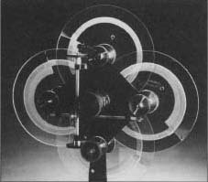

*Prismatic scanning disc mount made by C. Francis Jenkins in 1923.*

(From the collections of Henry Ford Museum & Greenfield Village.)

To the surprise of most people, television transmission began almost 25 years before the end of World War II. John Logie Baird, in England, and [C. Francis Jenkins](http://www.madehow.com/knowledge/Charles_Francis_Jenkins.html), in the United States, both made public demonstrations of television in 1925. Unlike post-war electronic televisions, these early systems used mechanical scanning methods.

Jenkins made significant contributions to optical transmission research during the 1920s. During 1922-23, he constructed mechanical prismatic disc scanners to transmit images. These scanners focused and refracted light through prisms ground into the edges of overlapping glass discs. As the discs rotated, a point of light scanned horizontally and vertically across a light-sensitive surface. This generated electrical signals necessary for transmission. In 1922 Jenkins sent facsimiles of photographs by telephone, and the following year transmitted images of President Harding and others by radio with an improved scanner. Unlike television, however, these first tests only sent still pictures.

Jenkins publicly broadcast moving images with his equipment in 1925. His first 10-minute broadcast showed in silhouette the motions of a small operating windmill. By 1931, he had experimental television stations operating in New York and Washington D.C. He sold receiver kits to those wishing to view his telecasts and encouraged amateur participation. With other companies, Jenkins contributed to a small, short-lived mechanical television "boom." By 1933, however, the poor image quality of mechanical scanning convinced larger manufacturers to pursue the possibilities of electronic technologies, and the mechanical television era ended.

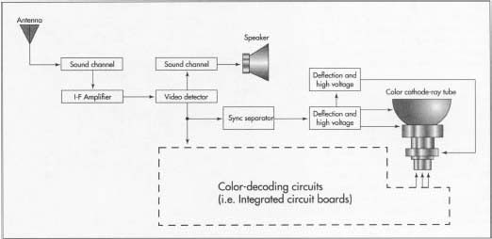

The design of the television requires input and teamwork on the part of a range of design engineers. Audio, video, plastics, fiber



Diagram of a television receiver.

optics, and electronics engineers all participate in conceptualizing a new television design and the technical and sales features that will set it apart. A new design of television may have one or many new applications of technology as features. It may only be a different size of an existing model, or it may include an array of new features such as an improved sound system, a remote control that also controls other entertainment devices, and an improved screen or picture, such as the flat black screens that have entered the marketplace recently.

Conceptual plans for the new set are produced by the engineering team. The concept may change and be redrawn many times before the design is preliminarily approved for manufacture. The engineering specialists then select and design the components of the set, and a prototype is made to prove out the design. The prototype is essential, not only for confirming the design, appearance, and function of the set, but also for production engineers to determine the production processes, machining, tools, robots, and modifications to existing factory production lines that also have to be designed or modified to suit the proposed new design. When the prototype passes rigid reviews and is approved for manufacture by management, detailed plans and specifications for design and production of the model are produced. Raw materials and components manufactured by others can then be ordered, the production line can be constructed and tested, and the first sets can begin their ride down the assembly line.

**The Manufacturing   
Process**

***Housing***

Almost all television housings are made of plastic by the process of injection molding, in which precision molds are made and liquid plastic is injected under high pressure to fill the molds. The pieces are released from the molds, trimmed, and cleaned. They are then assembled to complete the housing. The molds are designed so that brackets and supports for the various components are part of the housing.

***Picture tube***

The television picture tube, or cathode ray tube (CRT), is made of precision glass that is shaped to have a slightly curved plate at the front or screen. It may also have a dark tint added to the face plate glass, either during production of the glass or by application directly to the inside of the screen. Darker face plates produce improved picture contrast. When the tube is manufactured, a water suspension of [phosphor](http://www.madehow.com/knowledge/Phosphor.html)

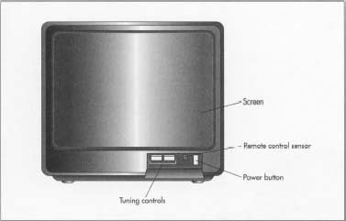

chemicals is allowed to settle on the inside of the face plate, and this coating is then overlaid with a thin film of aluminum that lets electrons pass through. The aluminum serves as a mirror to prevent light from bouncing back into the tube.

Glass for picture tubes is supplied by a limited number of manufacturers in Japan and Germany. Quantities of the quality of glass needed for picture tubes are limited, and the emergence of large-screen sets has created a shortage in this portion of the industry. The large screens are also very heavy, so flat-panel displays using plasma-addressed liquid crystal (PALC) displays were developed in the 1980s. This gas plasma technology uses electrodes to excite layers of neon or magnesium oxide, so they release ultraviolet radiation that activates the phosphor on the back of the television screen. Because the gas is trapped in a thin layer, the screen can also be thin and lightweight. Projection TVs use digital micro mirror devices (DMDs) to project their pictures.

A shadow mask with 200,000 holes lies immediately behind the phosphor screen; the holes are precisely machined to align the colors emitted by three electron beams. Today's best picture tubes have shadow masks that are manufactured from a nickel-iron alloy called Invar; lesser quality sets have masks of iron. The alloy allows the tube to operate at a higher temperature without distorting the picture, and higher temperatures allow brighter pictures. Rare-earth elements have also been added to the phosphor coating inside the tube to improve brightness.

The electrons are fired by three tubular, metal electron guns that are carefully seated in the neck, or narrow end, of the tube. After the electron guns are placed inside the tube, the picture tube is evacuated to a near vacuum so air does not interfere with the movement of the electrons. The small opening at the rear of the tube is sealed with a fitted electrical plug that will be positioned near the back of the set. A deflection yoke, consisting of several electromagnetic coils, is fitted around the outside of the neck of the picture tube. The coils cause pulses of high voltage to direct the scanning electron beams in the proper direction and speed.

***Audio parts***

The housing also contains fittings for speakers, wiring, and other parts of the audio system. The speakers are usually made by a specialized manufacturer to the specifications of the television manufacturer, so they are assembled in the set as components or a subassembly. Electronic sound controls and integrated circuitry are assembled in panels in the set as it travels along the assembly line.

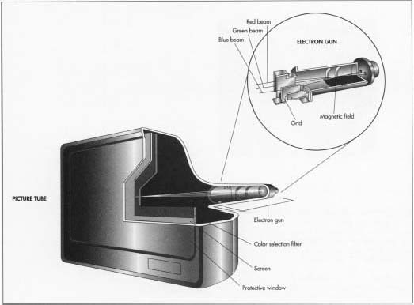

The electrons are fired by three tubular, metal electron guns seated in the neck, or narrow end, of the picture tube. After the electron guns are placed inside the tube, the picture tube is evacuated to a near vacuum so air does not interfere with the movement of the electrons. A color selection filter with 200,000 holes lies immediately behind the television screen; the holes are precisely machined to align the colors emitted by three electron beams.

**Electronic parts**

4 When the picture tube and the audio speakers and attachments are assembled in the set, other electronic elements are added to the rear of the set. The antennae, cable jacks, other input and output jacks, the electronics for receiving remote control signals, and other devices are prepared by specialty contractors or as subassemblies else-where on the assembly line. They are then mounted in the set, and the housing is closed.

**Quality Control**

As with all precision devices, quality control for the manufacture of the television is a rigid process. Inspections, laboratory testing, and field testing are performed during the development of prototypes and throughout manufacture so the resulting television is not only technologically sound but safe for use in homes and businesses.

**ISSUES**

**Backlight Issues**

The [LCD TV](https://www.ebay.com/sch/i.html?_nkw=lcd+tv) uses a backlight to illuminate the picture on the screen. When the backlight is experiencing problems, you may not see anything on the screen. To fix this problem, you will need to replace the backlight in the TV. Most people who are unfamiliar with how this works will need to hire a professional to replace the light. If your TV is new, you may be able to have it replaced under warranty by the manufacturer.

**Power Inverter**

Another issue that can lead to a blank image on the screen of your [LCD TV](https://www.ebay.com/sch/i.html?_nkw=lcd+tv) is a problem with the power inverter. The backlight on your LCD TV has a power inverter that could go bad as well. When this happens, you may need to replace the inverter or the capacitor. When an inverter is not functioning properly, it could look like the backlight is not working, when in reality, it is functioning fine.

**Power Supply**

In some cases, the power supply for the TV itself may not work correctly. When this happens, you will not be able to turn the TV on or display any images on the screen. If the power inverter for the backlight is not working, you will still be able to turn the TV on, but it will not display any images. When the power supply isn't working, you will not even be able to turn the TV on.

**Considerations**

If you can turn the TV on, but you are not seeing anything on the screen, try shining a light on the screen from an external light source, such as a flashlight. If you can see images or text displayed on the screen, it means that the TV is still working and the backlight is the issue. This could require either a backlight or a power inverter replacement. Contact your TV manufacturer or the seller of the TV to get assistance in this regard.

**Conclusion:**

Hence we have successfully studied on Manufacturing and Material Handling System.